TOF sub-trigger system
TOF sub-trigger is relatively simple, there are total 6 TOF trigger conditions. They are:
- NBTOF >= 1 : Number of hits of barrel TOF equal to or greater than 1.
- NBTOF >= 2 : Number of hits of barrel TOF equal to or greater than 2.
- NETOF >= 1 : Number of hits of endcap TOF equal to or greater than 1.
- NETOF >= 2 : Number of hits of endcap TOF equal to or greater than 2.
- TBB : Barrel TOF back to back. Refer to Fig. 4.1.
- ETBB : Endcap TOF back to back. Refer to Fig. 4.1.
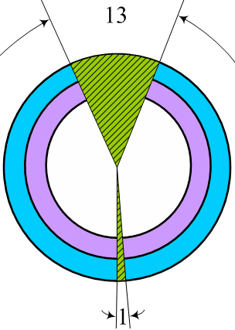

Fig. 4.1 TOF back to back (left : barrel, right : endcap)
Fig. 4.2 shows the sheme of the TOF sub-trigger system.
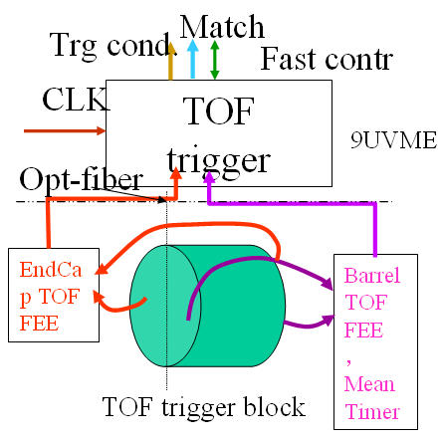

Fig. 4.2 Scheme of the TOF sub-trigger system

